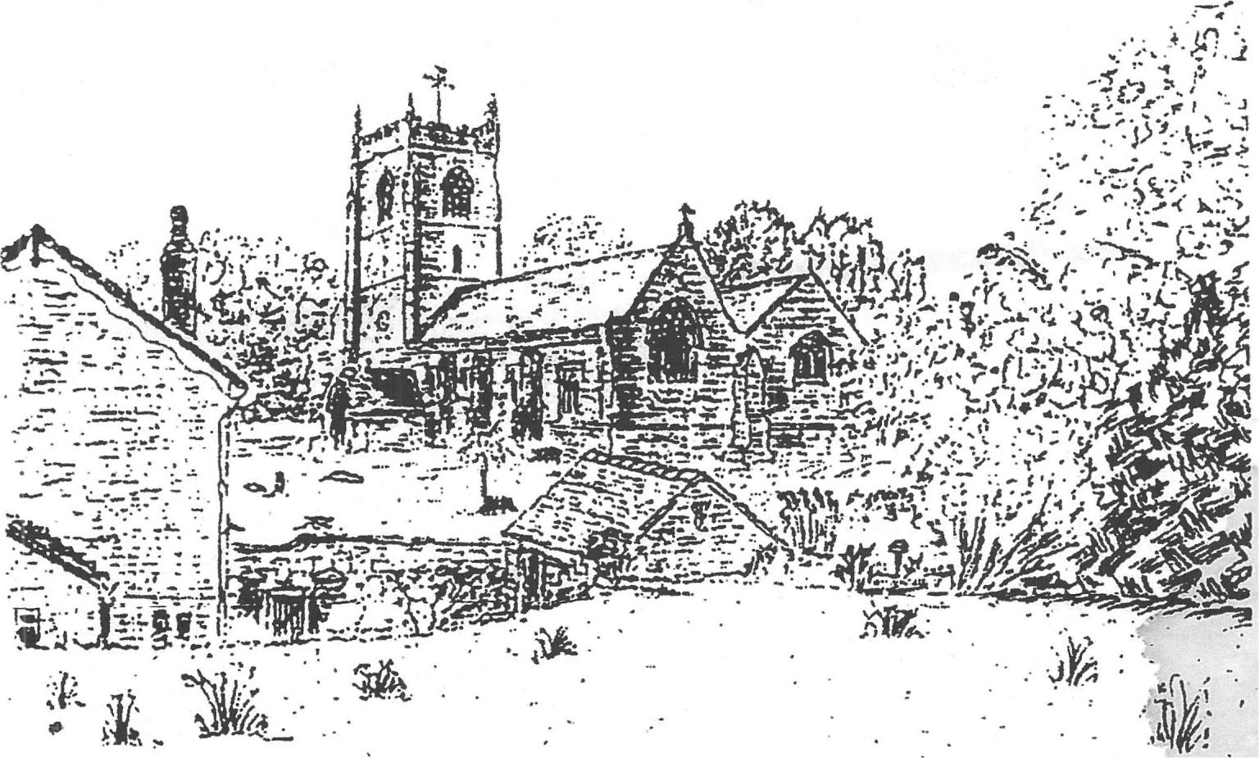
St. Mary's Church
Mucklestone

From an original drawing by Tony Fumival: @ AHF
You are .... fellow citizens with the saints and members of the household of God, built upon the foundation of the apostles
and prophets, . Christ Jesus himself being the cornerstone, in
whom the wole structure is joined together and grows into a
holy temple in the Lord; in whom you also are built into it for
a dwelling place of Clad in the Spirit. Eph 2:19-22

I AM
Alpha
the first

Welcome to St. Mary's Church, Mucklestone.
Mucklestone has had a church since Anglo-Saxon times. The
Domesday survey showed that in A.D. 1086 there was a priest here .There was .also a church of some kind with glebe land to maintain it. At a later date , probably in the reign of Henry II , Ivo de Pantolf appears to have given lands to Mucklestone for the upkeep of Combermere Abbey in Cheshire. It is thought that the Abbot of Combermere may have been for a time responsible for providing a parish-priest for Mucklestone until
the right of advowson was firstly vested in the lords of· the - manor of·Mucklestone of whom the first recorded is Walter de Muckleston c.1210. At all events, one can safely assume that the lords of the manor, their feudal overlords, the Bishops of Lichfield and the Abbot of Combermere carried out as best they could their spiritual duties towards the parishoners of St. Mary's, Mucklestone, in the early and later Middle Ages.
Evidently the parish church prospered, for it was rebuilt or enlarged to four stages in height probably in the 13th. C. The late 13th C tower stands today, lopped of one stage and retaining some good decorated 14th C work including the windows. The battlement parapet and pinnacles at the top of the tower are probably late 16th C additions. The church, including the old tower was again restored between 1786 and 1790, the nave and chancel being rebuilt in the low style of the period.
The most thorough restoration was carried out by the local architect Charles Lynam, in 1883 and principally at the expense of the Earl of Crewe, the patron. The nave and chancel were again completely rebuilt and enlarged and the ancient tower was entirely restored without the introduction of any new stonework.

The parish church today is a building of local sandstone,
consisting of a chancel of three bays, a nave of three bays,
and a north aisle to both nave and chancel. The main door is
in the south porch. At the east end is the raised sanctuary with
an oaken altar table. To the left and right of the altar, painted
on the east wall, are an unusual Alpha and Omega probably
dating from 1883. The chancel roof and beams of oak are
gaily painted, and the organ is now on the north side of the
choir-stalls. At the east end of the north aisle, to the north of
the chancel, is the Chetwode chapel. The Chetwodes were
lords of the manor of Oakley from the time of Richard II to this
century.

The splendid stained glass windows mentioned in a
note book of 1680 seem to have been removed by 1790. Now
the extremely fine stained glass is all of the late 19th C. There
are 13 windows by Kempe given by a former Lady Alice
Chetwode. The window at the west end is a magnificent
memorial to Queen Margaret, wife of Henry VI, and the Battle
of Blore Heath 1459. The east end window commemorates a
yet more significant conflict, the victory over evil through which
we obtain eternal salvation.

The visitor will discover
many other interesting
features of our beautiful
church. We hope however
that this brief introduction to
this lovely building has been
of help to you. We hope that
you will find a few moments
of peace and tranquility
within its walls, and if you
feel able to help us in our
constant efforts to preserve it
for future generations,·your
donation will be most
gratefully received.

-
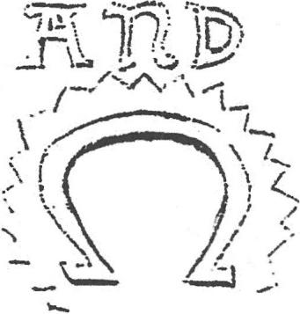
-i
__ 1
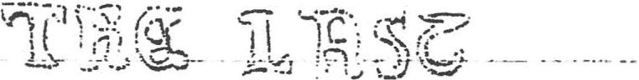

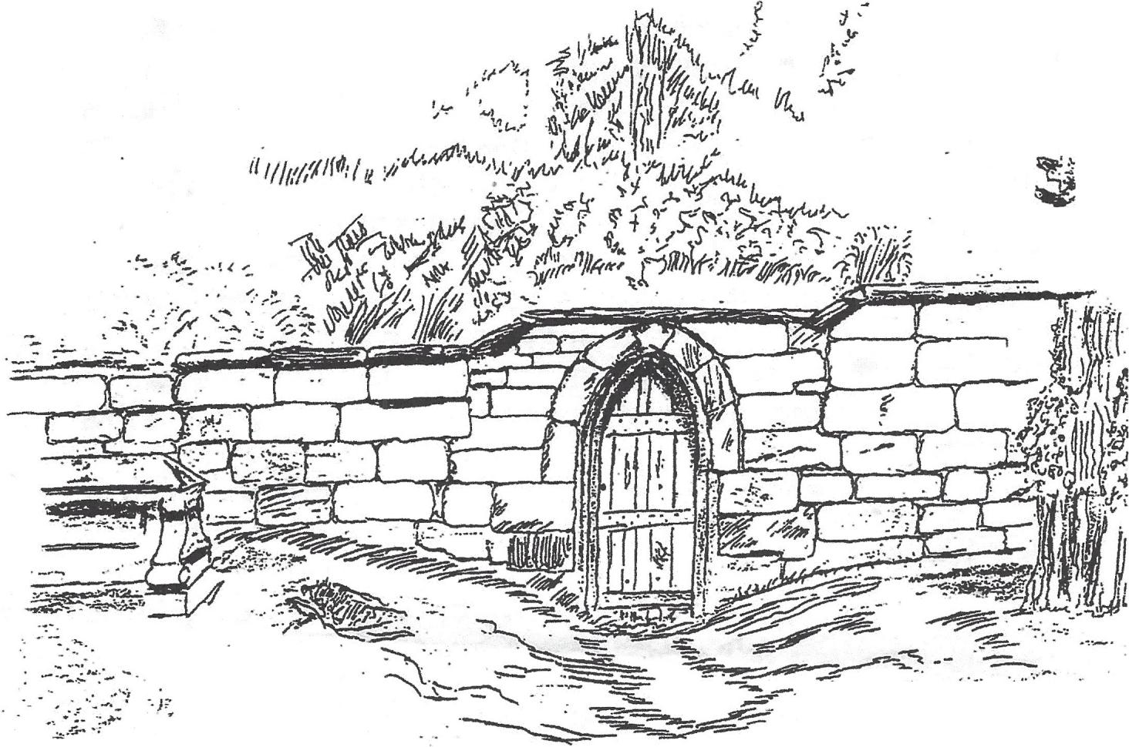

~ ._

,., ~ .
. J(,;

I . '~.,
../" .. ,
..
~

- A.H.F

In this is love: not that we loved God, but that he loved us and
sent his Son to be the expiation for our sins.

Through Jesus, then, let us continually offer up a sacrifice of
praise to God, that is, the fruit of lips that acknowledge his
name .

. I will.go unto the Altar of God,
unto the God of my joy and gladness.

With grateful thanks to Mrs Hilary Ainsworth

